Unit 8 Motivation, Emotion, and Stress PowerPoint Note Sheet

- _____________________
= a need or desire that energizes and directs behavior.
- ____________________
= a complex, unlearned behavior that is rigidly patterned throughout a species.
- ______________________
= the idea that a physiological need creates an aroused tension state (a drive) that motivates an organism to satisfy the need.
- ______________________
= a tendency to maintain a balanced or constant internal state; the regulation of any aspect of body chemistry, such as blood glucose, around a particular level.
- _____________________
= a positive or negative environment stimulus that motivates behavior.
- _____________________
= the principle that performance increases with arousal only up to a point, beyond which performance decreases.
- ______________________
= Maslow’s pyramid of human needs, beginning at the base with physiological needs that must first be satisfied before higher-level safety needs and then psychological needs become active.
- __________________
= the form of sugar that circulates in the blood and provides the major source of energy for body tissues. When its level is low, we feel hunger.
- __________________
= the point at which an individual’s “weight thermostat” is supposedly set. When the body falls below this weight, an increase in hunger and a lowered metabolic rate may act to restore the lost weight.
- ___________________________
= the body’s resting rate of energy expenditure.
- __________________________
= the four stages of sexual responding described by Masters and Johnson – excitement, plateau, orgasm, and resolution.
- ___________________________
= a resting period after orgasm, during which a man cannot achieve another orgasm.
- ___________________________
= a problem that consistently impairs sexual arousal or functioning.
- ______________________
= sex hormones, such as estradiol, secreted in greater amount by females than males and contributing to female sex characteristics. In nonhuman female mammals, estrogen levels peak during ovulation, promoting sexual receptivity.
- _________________
= the most important of the male sex hormones. Both males and females have it, but the additional testosterone in males stimulates the growth of the male sex organs in the fetus and the development of the male sex characteristics during puberty.
- _________________
= a response of the whole organism, involving
- (1) physiological arousal,
- (2) expressive behaviors, and
- (3) conscious experience.
- ___________________
= the theory that our experience of emotion is our awareness of our physiological responses to emotion-arousing stimuli.
- __________________________
= the theory that an emotion-arousing stimulus simultaneously triggers
- (1) physiological responses and
- (2) the subjective experience of emotion.

- _________________________
= the Schachter-Singer theory that to experience emotion one must (1) by physically aroused and (2) cognitively label the arousal.
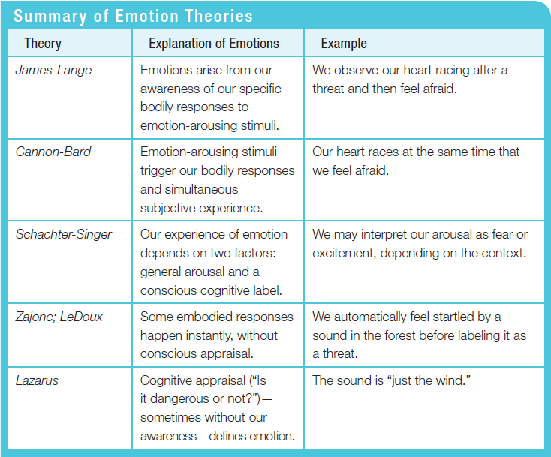

- _________________
= a machine, commonly used in attempts to detect lies, that measures several of the physiological responses (such as perspiration and cardiovascular and breathing changes) accompanying emotion.
- ___________________________
= the tendency of facial muscle states to trigger corresponding feelings such as fear, anger, and happiness.
- ____________________
= a subfield of psychology that provides psychology's contribution to behavioral medicine.
- __________________
= the process by which we perceive and respond to certain events, called stressors, that we appraise as threatening or challenging.
- __________________________________
= Selye’s concept of the body’s adaptive response to stress in three phases – alarm, resistance, exhausion.
- _________________________________
= under stress, people (especially women) often provide support to others (tend) and bond with and seek support from others (befriend).
- ________________________________
= literally, “mind-body” illness; any stress-related physical illness, such as hypertension and some headaches.
- ________________________________
= the study of how psychological, neural, and endocrine processes together affect the immune system and resulting health.
- _______________________
= the two types of white blood cells that are part of the body’s immune system; B lymphocytes form in the bone marrow and release antibodies that fight bacterial infections; T lymphocytes form in the thymus and other lymphatic tissue and attack cancer cells, viruses, and foreign substances.
- _______________________________
= the clogging of the vessels that nourish the heart muscle; the leading cause of death in many developed countries.
- _______________
= Friedman and Rosenman’s term for competitive, hard-driving, impatient, verbally aggressive, and anger-prone people.
- _______________
= Friedman and Rosenman’s term for easygoing, relaxed people.

